Windows PowerShell 3.0 First Steps

# Chapter 1

Get-Process  
Get-Service  
Get-Volume  
Get-NetAdapter  
Get-NetConnectionProfile  
Get-Culture Getting the current culture settings  
Get-Date  
Get-Help  
Get-Random  
Get-Random -Maximum 21 -Minimum 1  
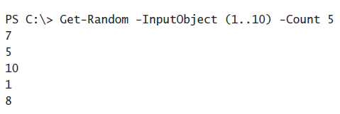  
PS C:\> ipconfig

# Chapter 2

**PowerShell parameters**

* **Verbose (vb)**

PS C:\> Stop-Process -Name notepad

* **Debug (db)**
* **WarningAction (wa)**
* **WarningVariable (wv)**
* **ErrorAction (ea)**

PS C:\> Get-Process -Name notepad -ErrorAction SilentlyContinue (geef error weergeven)

SilentlyContinue | Stop | Continue | Inquire | Ignore

* **ErrorVariable (ev)**
* **OutVariable (ov)**
* **OutBuffer (ob)**
* **WhatIf (wi)**
* **Confirm (cf)**

**PowerShell transcript**



<Commando’s + evt uitvoer>  
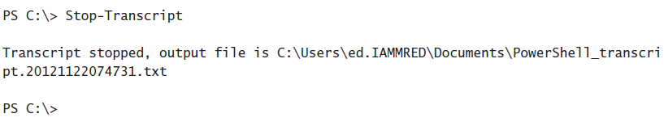Once you start the Windows PowerShell transcript, all commands, command output, and even error messages appear in the transcript file.

**Help**

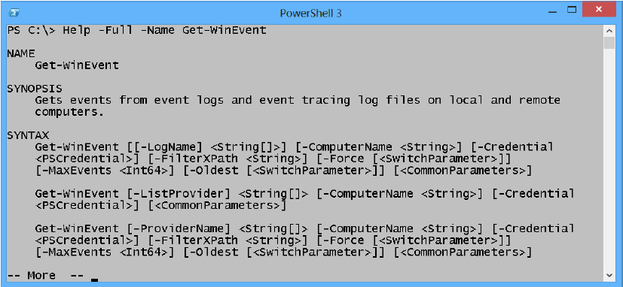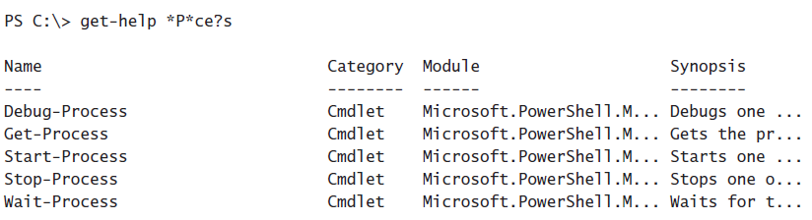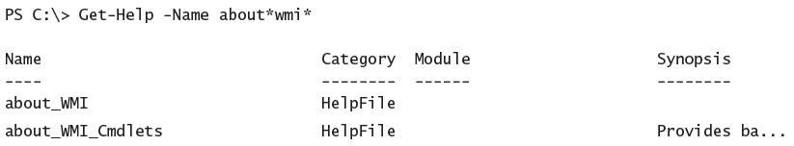

**Get-Command**

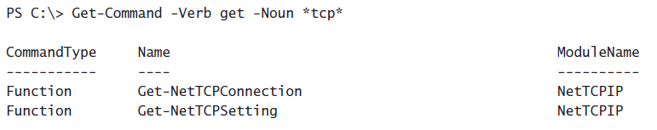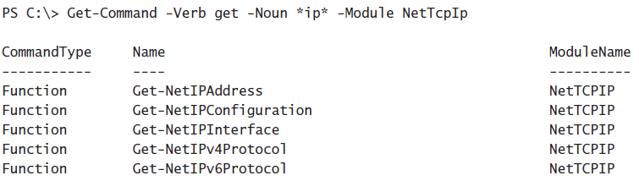

**Get-Member**

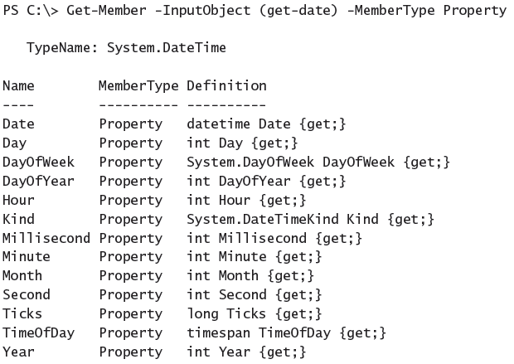

# Chapter 3

**Sort**

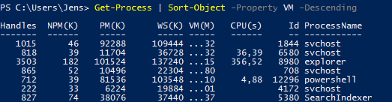  
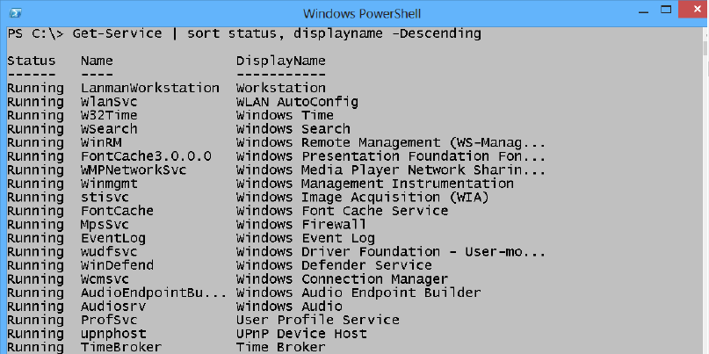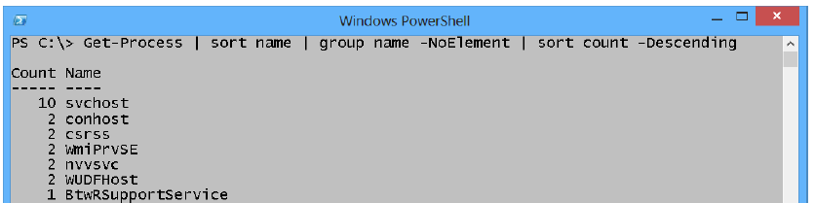

**Filtering**

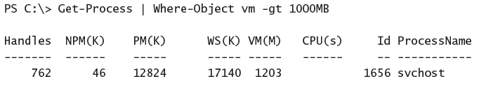  
  
-gt 🡪 greater than  
  
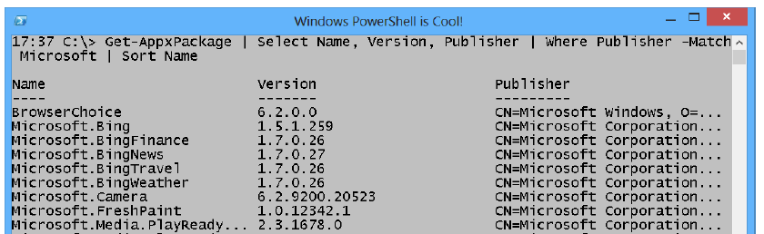

# Chapter 4

**Creating a table**

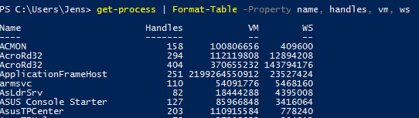

**Creating a list**

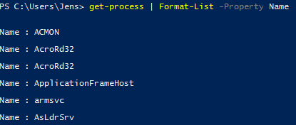 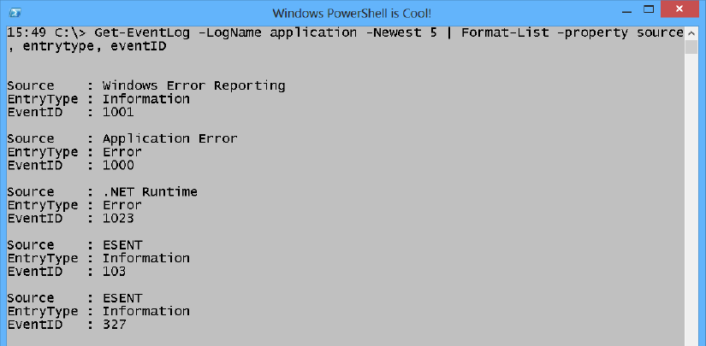

**Create a wide display**

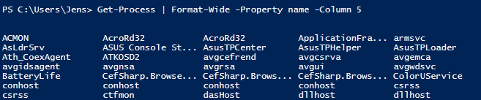

# 

# Chapter 5

**Storing data in text files**



**Storing data in CSV files**

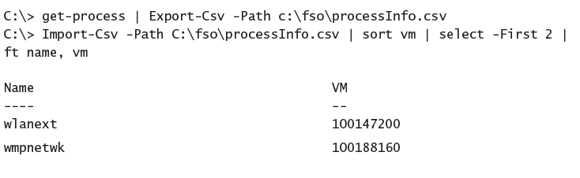

**Storing data in XML**

